To-do List Specification

This document is aimed at defining the features of the application and an application walkthrough detailing each screen feature.

# Features

This application has the following features:

* Create a to-do list
* Mark an item as complete
* Delete an item from the list
* Share to-do list items.

# Application Walkthrough

This application contains the following screens.

## Adding a to-do list item

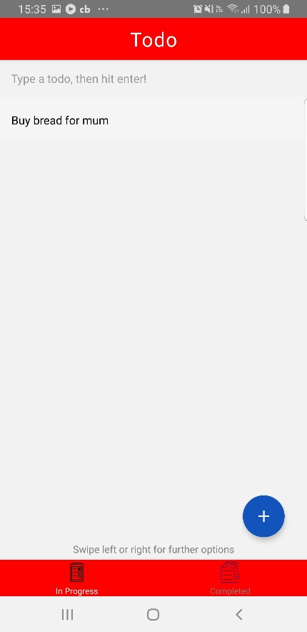The main screen contains 2 tabs. Typing in the text box above and selecting done on the keyboard will add the to-do item to the list.

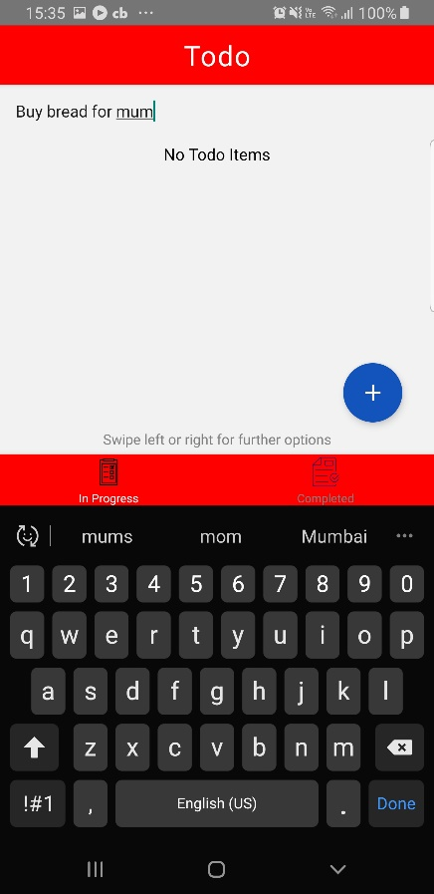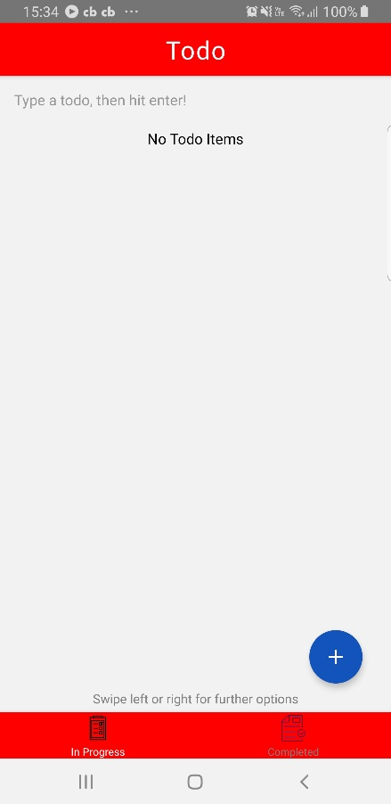

## Completing/Deleting an item

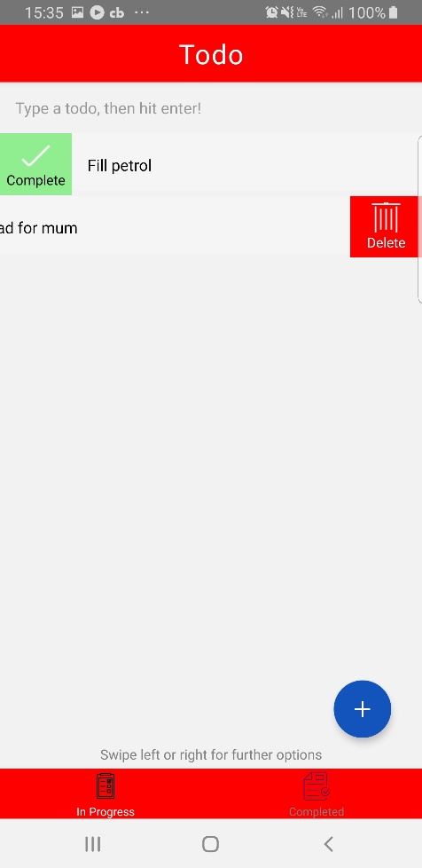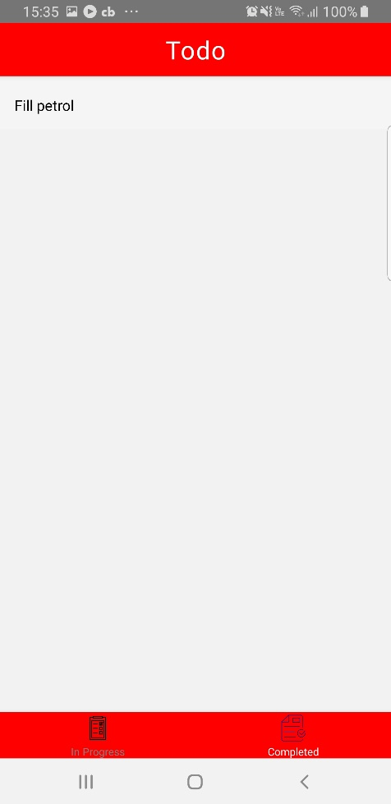Swiping left or right on the items will reveal a button i.e. complete or delete. Selecting “Complete” will remove the item from the “In Progress” tab list into the “Completed” tab list. Selecting “Delete” will remove the item from both lists/

## Share to-do list items

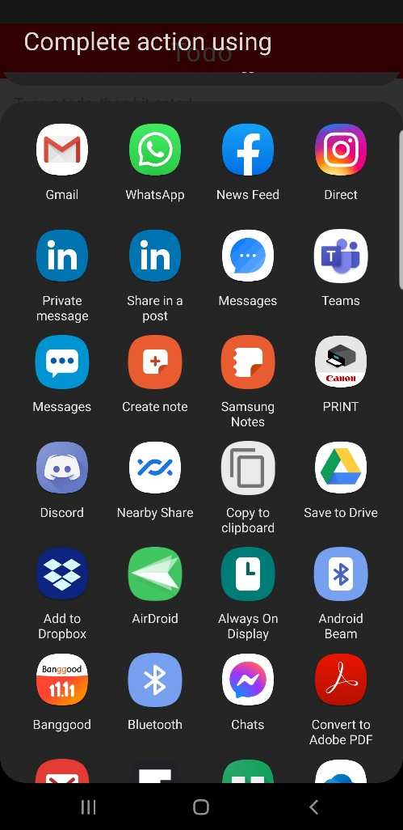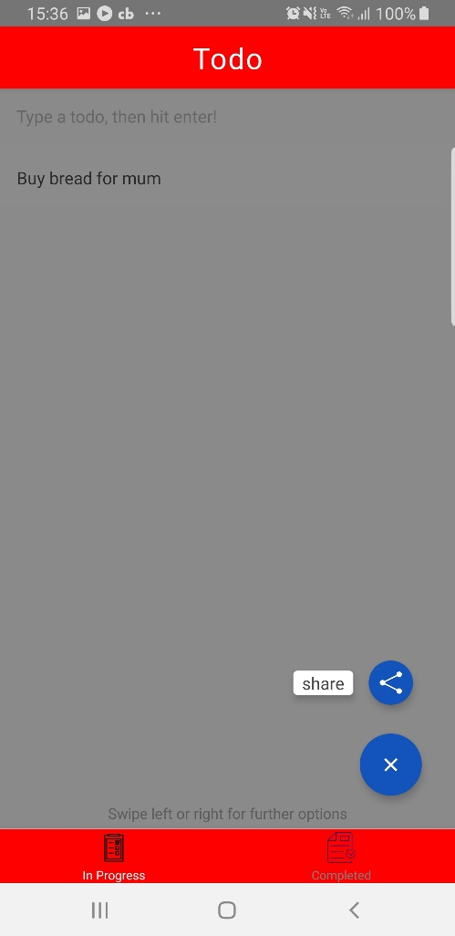Selecting the bottom right plus “+” button will reveal the share menu option. Selecting that option will reveal apps to share the to-do list i.e. Email , WhatsApp etc.